**11.10. TELENCO PRODUCTS FOR SSAC**

11.10.1. The following are most common (not exhaustive) Telenco products for the installation of  
SSAC cable for DII(F) and installation methods.

|  |  |  |
| --- | --- | --- |
| Item Code | Description | |
| UPB-01 6988 | Universal Pole Bracket – UPB. The UPB is fitted to poles, buildings and supporting structures for the anchoring of suspension devices. The UPB has three hole sets, each of which has a different function (explained throughout this document). |  |
| AC10-016970 | Anchoring Clamps – AC10  The AC10 is used for suspending aerial cables without the need fro removal of the PVC outer sheath of the suspension wire. The AC 10 is used for the suspension of ‘standard’ aerial cable and is denoted by a blue tab. |  |
| SWC63-016980 | Stay Wire Clamp - SWC  The Stay Wire Clamp (SWC) is used for terminating stay wire at the pole top and at the stay anchor. The SWC is marked with a yellow dot to differentiate it from the Bare Wire Clamp (BWC) (not shown). |  |
| ARC-0 16979 | Aerial Relief Clamp - ARC  The Aerial Relief Clamp (ARC) is used on intermediate poles in the Hooks Aerial Cable for straight line suspension of the cable. |  |
| EC13 | Earth Clamp - EC  The Earth Clamp (EC) is used for effecting an earth connection from the suspension wire when required i.e. for provision of lightning protection at buildings. The EC also allows for the connection of a 10mm earth cable. |  |

|  |
| --- |
| HAG 1A-01 6990 |

11.10.2. UPB (**Universal Pole Bracket).** The UPB bracket is designed to be installed on all types of poles and buildings. The UPB bracket has been developed to cover all the following installation parameters:

Hook Aerial Gable - HAG

The Hook Aerial Gable (HAG) is used at intermediate poles to provide the support for aerial cables. The HAG is used in conjunction with the ARG.

_Pic802

_Pic804

Terminating and Staying

Double Anchoring

Jointing and Terminating

Distribution Points

NID Issue 6.0 121 09 Nov 2006

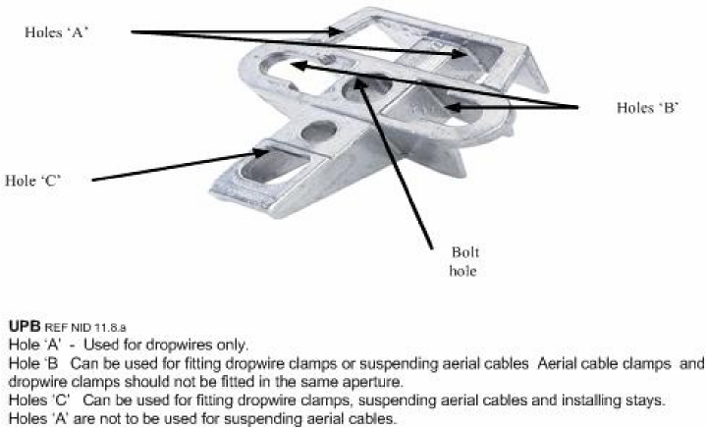

**Figure 46: UPB Installation Parameters**

11.10.3. **UPB Installation Procedure.**

1. Using the existing hole 200mm down from the top of the pole, insert the Bolt 16mm x 250mm, Bolt 16mm x 300mm or Bolt 16mm x 350mm through the central hole of the UPB Bracket and run it through the pole. Secure the bolt at the rear of the pole with one of the washers and nut supplied.
2. Bolt 16mm x 250mm, Bolt 16mm x 300mm and Bolt 16mm x 350mm are supplied  
   with two washers. Use one or two of the washers at the back of the pole, between the nut and the pole. Washers should not be fitted on the front of the UPB or between the UPB and Pole.

c. When terminating an end of route, the hole should be drilled inline to the pull on pole. Install two UPB Brackets, one to the front and the second at the rear of the pole to enable stays to be fitted.

11.10.4. **Aerial Cable Terminating Clamp.** The AC1 0-320 is suitable for use with 7 x 1.6mm  
multi-strand suspension wire. (Plastic Retaining Clip coloured Blue)

a. The AC1 0–320 Aerial Cable Terminating Clamps are designed to be installed  
directly onto the outer sheath of the suspension wire without having to strip off the insulation material. They should be used as a full termination system in the following situations:

1. Where jointing/DP points occur
2. Full terminations for road crossings

iii. Full terminations for field & gate openings

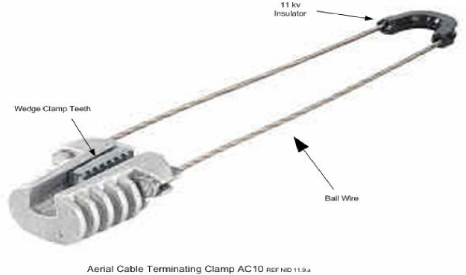

**Figure 47: Aerial Terminating Clamp**

NID Issue 6.0 123 09 Nov 2006

NID Issue 6.0 124 09 Nov 2006

_Pic819

NID Issue 6.0 125 09 Nov 2006

NID Issue 6.0 126 09 Nov 2006

11.10.5. **Aerial Cable Terminating Clamp Installation Procedure**

1. Pass the free end of the bail wire through apertures B or C (one clamp per aperture) of the UPB Bracket.
2. The clamp will hang easily by the 11kV thimble when situated in the central or lower apertures of the UPB Bracket. NOTE- THE 11kV THIMBLE MUST NEVER BE REMOVED FROM THE BAILWIRE.
3. Insert the free end of the bail wire into the open slot at the side of the clamp body.  
   This is easily achieved by holding the bail wire approximately 100 to 150mm back from the ferrule and sliding the bail wire on to the clamp body at an angle of approximately 30 degrees.
4. The clamp can be installed in any plane; however, the bail wires must NEVER touch  
   each other. Should the bail wires touch each other because of twisting, the cable should be re-tensioned and the bail wire inserted into the UPB in the reverse direction. If this does not resolve the issue of the bail wires touching, then ensure that there are only the required 7 or 8 anti-oscillation/anti-galloping twist in the span.
5. Ensure that the sliding wedges of the clamp are in the furthest back position to ensure the maximum aperture and place the AC 10 clamp body on to the insulated suspension wire. Push the jaws forward, ensuring that they are parallel and level.
6. When the AC1 0–320 Aerial Cable Terminating Clamp has been installed on the first pole, the engineer on the ground must ‘set’ the zinc alloy teeth by means of a strong pull on the cable.
7. Tension the cable in the appropriate method to 120% of its stringing tension. A dynamometer should be used to ensure an accurate cable tension.
8. It is recommended that the cable be tensioned level with the UPB Bracket to ensure ease of attaching the AC1 0–320 Aerial Cable Terminating Clamp to the cable.

i. With the cable tensioned to 120% of final installation tension, attach the bail wire to  
the body of the clamp and ensure that the wedges are in the fully opened position.

1. Extend the AC10–320 as far as possible out along the cable.
2. Place the alloy-toothed jaws onto the insulated suspension wire.
3. A small force should be applied and a positive reaction can be felt when the jaws  
   are fully and properly located. This is achieved by either the ground person setting the cable by a strong pull, at the start of the route or when at the end of the route by pulling the teeth into the body of the clamp. In cold weather, to assist the jaws in setting a gentle tap on the rear of the teeth with a wooden or plastic implement. Do not strike the jaws with any metal tools as this may damage the clamp.
4. Pull the body of the AC 10–320 Aerial Cable Terminating Clamp backward to set the teeth into the insulation of the suspension wire.
5. Release the tension from the cable.
6. The cable will move back into its locked/stringing position and thus complete the installation of the AC1 0–320 Aerial Cable Terminating Clamp.
7. On poles where the cable is running straight through, a short loop of cable must be left between the clamps. The loop shall be cleated to the pole and must not be rubbing on the bail wire.
8. Full termination using the Universal Pole Bracket and Anchoring Clamps (below).

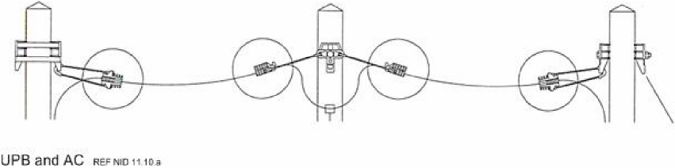

**Figure 48: Typical UPB and AC in Use**

11.10.6. **SSAC Power Crossings.**

1. Where SSAC crosses a power route, the suspension wire must be isolated at both poles on either side of the power crossing. This is achieved by introducing a large enough loop between the clamps to remove a minimum of 310mm (12”) section of the suspension wire. Cut out the steel suspension wire between these two points on each pole on either side of the power crossings. The loop shall be fastened to the pole.
2. An earth bonding clamp shall be installed at both ends of the span where the power and the SSAC cable intersect. The open side of the Earth Clamp shall be placed on to the insulated or bare suspension wire and a 10mm copper earthing wire introduced into the other side of the clamp. Tighten the nut until both wires have good electrical continuity. The10mm copper eathing wire shall be run down the pole to an earthing point at ground level, or to an un-insulated stay wire. The maximum diameter wire for the EC13 is 13mm on either side.

c. All earthing shall be tested and certified (with appropriate test certificate) as  
required. The figure below depicts the SSAC with the suspension wire being removed. The suspension wire that crosses the power must be earthed.

_Pic829

**Figure 49: Typical SSAC Crossing Power with Suspension Wire Earth**

11.10.7. **Aerial Cable Relief Clamp (ARC) and Hook Aerial Cable (HAC).** The Aerial Cable Relief Clamp is used in-line at intermediate poles in conjunction with the Hook Aerial Cable. The ARC is composed of a pair of UV resistant thermoplastic jaws forming a straight groove and two tightening bolts. The nylon parts provide an 11 kv dielectric insulation between the cable suspension wire and the pole/clamp.

11.10.8. **ARC and HAC Installation Procedures.**

Install the HAC at the required height needed. Place the ARC over the existing through bolt as shown below. Lift up the cable and insert the suspension wire in the clamp jaws. Tighten the two nuts of the clamp using a 13mm spanner. Binding-in is not required.

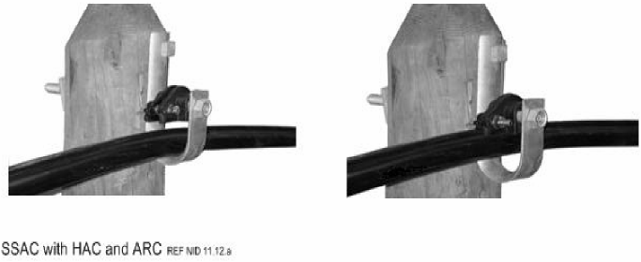

**Figure 50: SSAC with HAC and ARC**

11.10.9. **SSAC Building Entry**

1. When the suspension wire is to be attached directly to the wall of the building, the  
   use of the UPB, the Telenco wall bracket and the AC10 are to be used. The use of the fixed wall brackets may be suitable for buildings of a brick construction; however spreader plates or internal plates may have to be used for pre-fabricated style buildings.
2. When the scaffold pole is used to obtain more height, the UPB shall be attached to the scaffold pole with the Telenco approved banding method and product.
3. Allowing a drip loop of approx 200mm, the suspension wire shall be removed and terminated (as required) and secured to the building.
4. The attachment should be placed within 600mm of the bldg entry point, however if  
   this cannot be achieved the SSAC shall be placed in external grade/heavy grade trunking throughout its length to the building entry point (with suspension wire removed).
5. The SSAC shall be terminated inside the building. The fibre shall transition from external to internal as required.
6. The bend radius of the SSAC shall be maintained at all times.